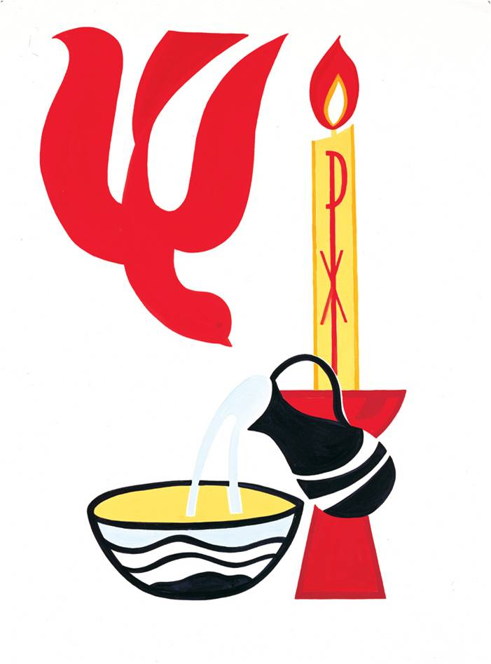Sacred Heart Church, Roscommon
St. Joseph's Church, Kilteevan
Tel: 090 6626298 / Email: roscommonparish3@gmail.com
(Copy of Civil Birth certificate for the child to be baptised must be attached)
Baptismal Form

Child's Surname: _______________________________________

Child's Christian name(s): _______________________________________

Date of Birth: (copy of birth certificate to be attached) ____________________________________________________________________

Father’s Surname: ____________________ Christian Name:____________________

Mother's Surname : ____________________ Christian Name:____________________
(Maiden Name)

Address of Parents:______________________________________________________

_____________________________________________________________________

Phone Number:____________________ Email: _______________________________

Proposed Date and Time of Baptism: ________________________________________

Date & Place of Church Marriage of Parents:___________________________________
(If applicable)
____________________________________________
Does your request for Baptism reflect your commitment to bring your child up in the Catholic faith? ______________________________________________

God-Parent’s Names and Addresses:

- __________________________________________________________________

- __________________________________________________________________

We request Baptism for our child. We consent to have details of our child's Baptism included in the Parish Newsletter & on the Parish Website.

Signature of Mother:___________________ Signature of Father: __________________

Offerings can be given with return of form or on the day – thank you for your support.

“Baptism is the Greatest Gift we can receive, but with the gift comes great responsibility.”

